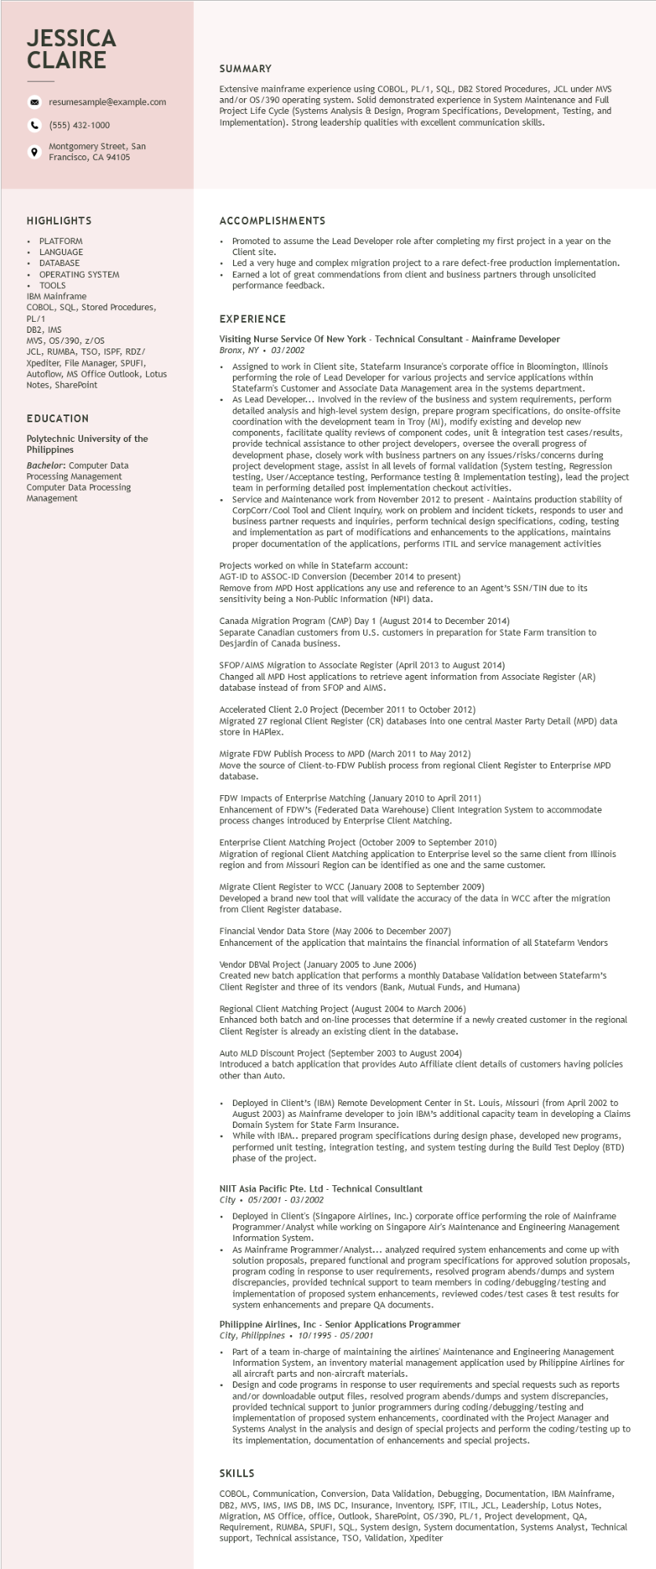
JESSICA CLAIRE
9
resumesample@example.com
(555) 432-1000
Montgomery Street, San Francisco, CA 94105
SUMMARY
Extensive mainframe experience using COBOL, PL/1, SQL, DB2 Stored Procedures, JCL under MVS and/or OS/390 operating system. Solid demonstrated experience in System Maintenance and Full Project Life Cycle (Systems Analysis & Design, Program Specifications, Development, Testing, and Implementation). Strong leadership qualities with excellent communication skills.
HIGHLIGHTS
PLATFORM
LANGUAGE
DATABASE
OPERATING SYSTEM
TOOLS
IBM Mainframe
COBOL, SQL, Stored Procedures,
PL/1
DB2, IMS
MVS, OS/390, z/OS
JCL, RUMBA, TSO, ISPF, RDZ/
Xpediter, File Manager, SPUFI, Autoflow, MS Office Outlook, Lotus Notes, SharePoint
EDUCATION
Polytechnic University of the Philippines
Bachelor: Computer Data Processing Management Computer Data Processing Management
ACCOMPLISHMENTS
Promoted to assume the Lead Developer role after completing my first project in a year on the Client site.
Led a very huge and complex migration project to a rare defect-free production implementation. Earned a lot of great commendations from client and business partners through unsolicited performance feedback.
EXPERIENCE
Visiting Nurse Service Of New York - Technical Consultant - Mainframe Developer Bronx, NY 03/2002
• Assigned to work in Client site, Statefarm Insurance's corporate office in Bloomington, Illinois performing the role of Lead Developer for various projects and service applications within Statefarm's Customer and Associate Data Management area in the systems department.
As Lead Developer... Involved in the review of the business and system requirements, perform detailed analysis and high-level system design, prepare program specifications, do onsite-offsite coordination with the development team in Troy (MI), modify existing and develop new components, facilitate quality reviews of component codes, unit & integration test cases/results, provide technical I assistance to other project developers, oversee the overall progress of Dect develope development phase, closely work with business partners on any issues/risks/concerns during formal project development stage, assist in all levels of formal validation (System testing, Regression testing, User/Acceptance testing, Performance testing & Implementation testing), lead the project team in performing detailed post implementation checkout activities.
Service and Maintenance work from November 2012 to present - Maintains production stability of CorpCorr/Cool Tool and Client Inquiry, work on problem and incident tickets, responds to user and business partner requests and inquiries, perform technical design specifications, coding, testing and implementation as part of modifications and enhancements to the applications, maintains proper documentation of the applications, performs ITIL and service management activities
Projects worked on while in Statefarm account:
AGT-ID to ASSOC-ID Conversion (December 2014 to present)
Remove from MPD Host applications any use and reference to an Agent's SSN/TIN due to its sensitivity being a Non-Public Information (NPI) data.
Canada Migration Program (CMP) Day 1 (August 2014 to December 2014)
Separate Canadian customers from U.S. customers in preparation for State Farm transition to Desjardin of Canada business.
SFOP/AIMS Migration to Associate Register (April 2013 to August 2014)
Changed all MPD Host applications to retrieve agent information from Associate Register (AR) database instead of from SFOP and AIMS.
Accelerated Client 2.0 Project (December 2011 to October 2012)
Migrated 27 regional Client Register (CR) databases into one central Master Party Detail (MPD) data store in HAPlex.
Migrate FDW Publish Process to MPD (March 2011 to May 2012)
Move the source of Client-to-FDW Publish process from regional Client Register to Enterprise MPD database.
FDW Impacts of Enterprise Matching (January 2010 to April 2011)
Enhancement of FDW's (Federated Data Warehouse) Client Integration System to accommodate process changes introduced by Enterprise Client Matching.
Enterprise Client Matching Project (October 2009 to September 2010)
Migration of regional Client Matching application to Enterprise level so the same client from Illinois region and from Missouri Region can be identified as one and the same customer.
Migrate Client Register to WCC (January 2008 to September 2009)
Developed a brand new tool that will validate the accuracy of the data in WCC after the migration from Client Register database.
Financial Vendor Data Store (May 2006 to December 2007)
Enhancement of the application that maintains the financial information of all Statefarm Vendors
Vendor DBVal Project (January 2005 to June 2006)
Created new batch application that performs a monthly Database Validation between Statefarm's Client Register and three of its vendors (Bank, Mutual Funds, and Humana)
Regional Client Matching Project (August 2004 to March 2006)
Enhanced both batch and on-line processes that determine if a newly created customer in the regional Client Register is already an existing client in the database.
Auto MLD Discount Project (September 2003 to August 2004)
Introduced a batch application that provides Auto Affiliate client details of customers having policies other than Auto.
Deployed in Client's (IBM) Remote Development Center in St. Louis, Missouri (from April 2002 to August 2003) as Mainframe developer to join IBM's additional capacity team in developing a Claims Domain System for State Farm Insurance.
While with IBM.. prepared program specifications during design phase, developed new programs, performed unit testing, integration testing, and system testing during the Build Test Deploy (BTD) phase of the project.
NIIT Asia Pacific Pte. Ltd - Technical Consultlant City
05/2001-03/2002
• Deployed in Client's (Singapore Airlines, Inc.) corporate office performing the role of Mainframe Programmer/Analyst while working on Singapore Air's Maintenance and Engineering Management Information System.
• As Mainframe Programmer/Analyst... analyzed required system enhancements and come up with solution proposals, prepared functional and program specifications for approved solution proposals, program coding in response to user requirements, resolved program abends/dumps and system discrepancies, provided technical support to team members in coding/debugging/testing and implementation of proposed system enhancements, reviewed codes/test cases & test results for system enhancements and prepare QA documents.
Philippine Airlines, Inc - Senior Applications Programmer City, Philippines 10/1995 - 05/2001
.
Part of a team in-charge of maintaining the airlines' Maintenance and Engineering Management Information System, an inventory material management application used by Philippine Airlines for all aircraft parts and non-aircraft materials.
Design and code programs in response to user requirements and special requests such as reports and/or downloadable output files, resolved program abends/dumps and system discrepancies, provided technical support to junior programmers during coding/debugging/testing and implementation of proposed system enhancements, coordinated with the Project Manager and Systems Analyst in the analysis and design of special projects and perform the coding/testing up to its implementation, documentation of enhancements and special projects.
SKILLS
COBOL, Communication, Conversion, Data Validation, Debugging, Documentation, IBM Mainframe, DB2, MVS, IMS, IMS DB, IMS DC, Insurance, Inventory, ISPF, ITIL, JCL, Leadership, Lotus Notes, Migration, MS Office, office, Outlook, SharePoint, OS/390, PL/1, Project development, QA, Requirement, RUMBA, SPUFI, SQL, System design, System documentation, Systems Analyst, Technical support, Technical assistance, TSO, Validation, Xpediter

